2.77: Let t₁ be the fall for the watermelon, and t₂ be the travel time for the sound to return. The total time is 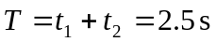. Let y be the height of the building, then, 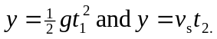 There are three equations and three unknowns. Eliminate t₂, solve for t₁, and use the result to find y. A quadratic results: 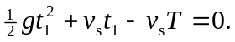 If
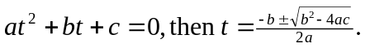

Then upon substituting these values into the quadratic formula,

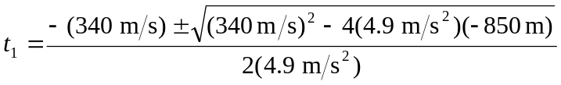

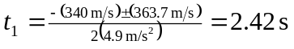. The other solution, –71.8 s has no real physical meaning. Then, Check: 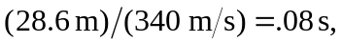 the time for the sound to return.

